

**Colloquium – A Career Guidance Support AI system**

**Web Project ( Trimester IV )**

**System Requirement Specification Document**

**Submitted by**

**Ritwika Das Gupta (2348049)**

**Sayantan Ray (2348057)**

**Soham Chatterjee (2348062)**

**Table of Contents**

1. INTRODUCTION 4

1.1 Problem description: 4

1.2 Objective: 4

2. LITERATURE SURVEY 5

2.1 Existing system 5

2.2 Limitations of the existing system 5

2.3 methodology of previous studies: analysis 6

3. PROJECT STUDY 6

3.1 Proposed system: 6

3.2 Benefits of the proposed system 7

4. SYSTEM MODEL 7

4.1 FEATURES OF THE PROPOSED SYSTEM (under system model) 7

5. SYSTEM REQUIREMENTS SPECIFICATION 9

5.1 USER CHARACTERISTICS 9

5.2 SOFTWARE AND HARDWARE REQUIREMENTS 9

5.3 END-USERS 9

6. FUNCTIONAL REQUIREMENT 10

7. NON-FUNCTIONAL REQUIREMENT 11

7.1 CONSTRAINTS 11

7.2 Response Time 11

7.3 Security 11

7.4 Reusability 11

7.5 Modifiability 12

8. PROJECT ROLES 12

9. TIME LINE 12

**Abstract**

This study examines the creation of an AI-driven career guidance platform that delivers personalized and data-based insights and recommendations. A key feature is the AI interview bot, which conducts mock interviews based on users' resumes and queries, providing feedback and scores. The platform also includes a chatbot for handling text and image queries, improving user interaction and support. Additionally, it uses machine learning to recommend relevant research papers, aiding users in their professional growth. By focusing on personalization, market alignment, and interview preparation, the platform aims to make career planning more efficient and accessible for a wide range of users.

**SYSTEM REQUIREMENT SPECIFICATION**

# INTRODUCTION

## 1.1 Problem description:

In today's dynamic job market, individuals often face challenges in navigating career paths and making informed decisions regarding their professional development. Traditional career guidance methods are frequently outdated and unable to cater to the unique needs of each individual. Additionally, the overwhelming amount of available information makes it difficult for users to find relevant and personalized advice, leading to suboptimal career choices and job dissatisfaction.

To address these challenges, we propose an intelligent, AI-driven career guidance platform that offers personalized, data-driven insights and recommendations. This platform aims to analyze various factors, including user preferences, market trends, and skill requirements, to provide tailored career advice aligned with individual goals and the current job market landscape.

A key feature of this platform is an AI-driven interview bot designed to enhance user experience. This bot will conduct simulated interviews based on the user's resume and queries, providing a realistic interview practice environment. Additionally, if feasible, the bot will offer feedback and grading on the user's performance, helping them identify strengths and areas for improvement.

Moreover, the platform will include a chatbot for text and image queries, making it stand out from other systems by offering comprehensive and multimodal support. This feature will enhance user engagement and provide a more interactive experience. By incorporating machine learning models, the platform will also recommend relevant research papers based on user queries, further aiding in professional development.

## 1.2 Objective:

**Personalization:**

Provide customized career guidance based on individual user profiles, preferences, and goals.

**Market Alignment:**

Offer up-to-date information on market trends, in-demand skills, and job opportunities to ensure users make informed career decisions.

**Interview Preparation:**

Use an AI-driven interview bot to conduct mock interviews tailored to the user’s resume and career goals.

Offer feedback and grading on interview performance, if feasible, to help users improve their skills.

**Multimodal Support:**

Implement a chatbot for both text and image queries to provide comprehensive support and enhance user engagement.

**Research Paper Recommendations:**

Utilize machine learning models to recommend relevant research papers based on user queries, supporting continuous learning and professional development.

**Efficiency:**

Streamline the career planning process by reducing the time and effort required to gather and analyze career-related information.

**Accessibility:**

Ensure the platform is accessible to a wide audience, including individuals from diverse backgrounds and locations.

**User Satisfaction:**

Enhance user satisfaction by helping individuals find career paths that align with their interests and strengths, leading to increased job satisfaction and professional fulfillment.

# LITERATURE SURVEY

## 2.1 Existing system

Several AI-powered career guidance systems offer unique features to support job seekers in various aspects of their career journeys. **Jobscan** uses AI to optimize resumes for applicant tracking systems (ATS), providing insights on job descriptions, keywords, and how to tailor resumes for specific roles. **CareerBuilder** offers a career change program with personalized mentoring and job support, leveraging AI to provide job placement assistance and career coaching.

## 2.2 Limitations of the existing system

These existing AI career guidance systems have various limitations. **Jobscan**, for instance, focuses specifically on resume tracking and answering questions related to resumes. While it excels in optimizing resumes for applicant tracking systems (ATS) and tailoring them for specific roles, it remains limited to resume-related functionalities. In contrast, our system offers a module for document scanning and answering related questions, but it also integrates other modules, providing a more comprehensive career support experience beyond just resumes. **CareerBuilder** provides career guidance and coaching support, but its scope is mainly on mentoring and job placement assistance. Our system goes further by incorporating AI-generated mock interview practice, albeit on a smaller scale, offering users practical preparation for job interviews. This holistic approach aims to address more aspects of the career development process, enhancing overall support for job seekers.

## methodology of previous studies: analysis

Table 1.0: Methodology of previous studies report

|  |  |  |  |
| --- | --- | --- | --- |
| Year of Implementation | AI Name | Techniques/Algorithm | Gap or Drawback |
| 2018 | Pymetrics | Neuroscience-based Games, ML | Limited scope of assessment, potential biases in games |
| 2019 | HireVue | Video Interview Analysis, AI, ML | Potential bias in AI algorithms, privacy concerns |
| 2020 | MyInterview | AI Video Analysis, NLP, ML | Limited language support, privacy and data security issues |
| 2021 | Talview | Behavioral Insights, AI, ML | High dependency on video quality, potential bias issues |
| 2022 | InterviewStream | Video Interviewing, AI Analysis | Requires strong internet connection, potential bias in evaluations |
| 2023 | Vervoe | Skill Assessment, AI Scoring | May not cover all skill types accurately, potential biases |
| 2018 | JobPal | Chatbot, NLP, ML | Limited conversation complexity, potential language support issues |
| 2023 | Iris.ai | AI, NLP, Research Paper Recommendation | May struggle with niche topics, requires large data sets for accuracy |

# PROJECT STUDY

## 3.1 Proposed system:

The proposed system is an advanced AI-driven career guidance platform designed to provide holistic support to job seekers and professionals. Integrating multiple modules, this system offers comprehensive solutions for document summarization, career-specific advice, language learning, interview preparation, and material recommendations. By leveraging cutting-edge technology, it aims to enhance the job search process, streamline career development, and equip users with the tools they need to succeed in today's competitive job market.

The proposed system includes five key modules: a document summarizer that analyzes and condenses resumes or documents while answering related questions, a career-specific chatbot that provides tailored advice through audio and text prompts, a language learning support bot that helps users learn new languages through translation and practice, an interview bot that prepares users with domain-specific questions and realistic audio conversations, and a material recommendation module that suggests relevant preparation resources for various domains. Together, these modules offer a comprehensive and interactive career guidance experience.

## 3.2 Benefits of the proposed system

The proposed system offers numerous benefits for users seeking comprehensive career support. It provides:

1. **Efficient Document Management**: The document summarizer saves time by quickly summarizing resumes and documents, offering concise answers to related questions.

2. **Personalized Career Guidance**: The career-specific chatbot delivers tailored advice, addressing individual career queries through convenient audio and text prompts.

3. **Enhanced Language Learning**: The language learning support bot facilitates language acquisition, helping users learn new languages effectively through translation and interactive practice.

4. **Improved Interview Preparation**: The interview bot offers realistic interview practice, boosting users' confidence and readiness with domain-specific questions and audio conversation support.

5. **Targeted Resource Recommendations**: The material recommendation module ensures users have access to high-quality, domain-specific preparation materials, enhancing their knowledge and skills for career advancement.

# 4. SYSTEM MODEL

## 4.1 FEATURES OF THE PROPOSED SYSTEM (under system model)

The proposed system encompasses five major modules designed to offer comprehensive career guidance and support:

1. **Document Summarizer**: This module is designed to analyze and summarize given resumes or documents, providing concise and relevant information. It can answer any questions related to the specific document, making it easier for users to extract key details and understand their content quickly. This goes beyond traditional resume optimization by offering a more interactive and detailed document analysis.

2. **Career-Specific Chatbot**: This chatbot is tailored to provide career-related guidance through both audio and text prompts. It can handle various career-related questions and offer solutions, assisting users in navigating their career paths, exploring job opportunities, and obtaining personalized advice. By supporting multiple input formats, it ensures accessibility and convenience for users with different preferences.

3. **Language Learning Support Bot**: This bot assists users in learning new languages by enabling them to type in their native language and receive translations and learning support in the target language. It offers an interactive way to practice and improve language skills, making it easier for users to acquire new languages for career advancement or personal growth.

4. **Interview Bot**: This module prepares users for job interviews by taking a specific domain and asking relevant questions. It simulates real interview scenarios, incorporating audio conversations from both sides to enhance the practice experience. Users can improve their interview skills and gain confidence through this interactive and realistic preparation tool.

5. **Material Recommendation**: This module recommends preparation materials based on specific domains, providing users with targeted resources to enhance their knowledge and skills. Whether it's study guides, articles, or practice exercises, this feature ensures users have access to relevant and high-quality materials to support their career development and learning goals.

* 1. 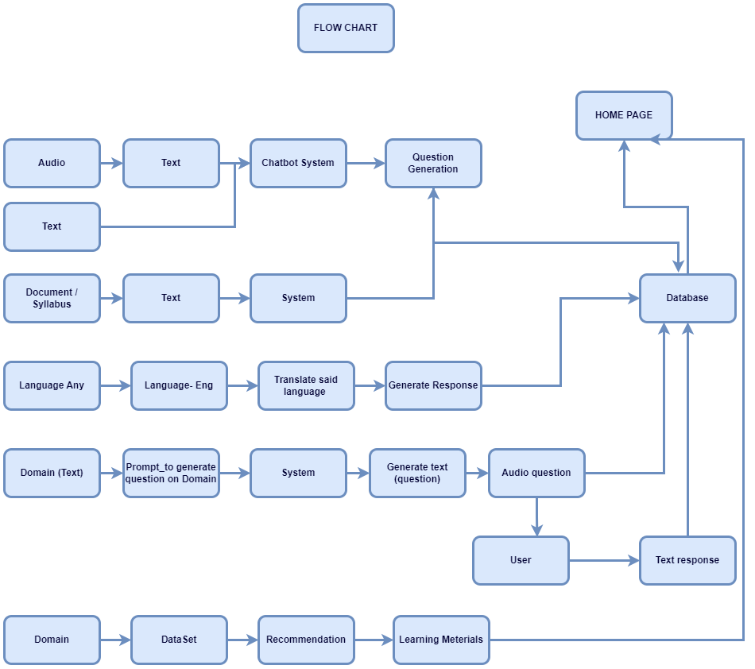**Fig 1: Showing the flowchart of our proposed system model.**

# SYSTEM REQUIREMENTS SPECIFICATION

## 5.1 USER CHARACTERISTICS

The proposed system is particularly beneficial for users with various data science backgrounds, helping them achieve their career goals with tailored support. It provides efficient document management through summarization and question answering, personalized career guidance via a responsive chatbot, and enhanced language learning support for acquiring new languages. The system also improves interview preparation with domain-specific questions and audio conversations, and it offers targeted resource recommendations to ensure access to relevant materials. This comprehensive approach equips data science professionals with the necessary tools and insights to advance in their careers.

|  |  |
| --- | --- |
| **Requirement** | **Characteristics** |
| Software | GPU cloud based notebook running environments- Google Colab, Kaggle,  Gradio, Streamlit, Huggingface Interface Support. HTML, CSS, JS , backend PHP support savings in txt/csv formats, Python Flask |
| Hardware | Cloud systems required not supported in hardware. |

## 5.2 SOFTWARE AND HARDWARE REQUIREMENTS

|  |  |
| --- | --- |
| **Requirement** | **Characteristics** |
| Software | Browser (Google Chrome (>4.0), Safari (>5.0), Mozilla Firefox  (5.0)) |
| Hardware | At least 2 GB RAM, Internet connectivity. |

## 5.3 END-USERS

# FUNCTIONAL REQUIREMENT

|  |  |  |
| --- | --- | --- |
| **Requirement ID** | **Requirement** | **Description** |
| M1_FR1 | Document Summarization | The Document Summarizer analyzes and extracts key information from resumes and documents, generating concise summaries and providing answers to related queries. This module enhances document comprehension and reduces the time needed for review. |
| M1_FR2 | Carrier Specific Chabot | The Career-Specific Chatbot accepts audio and text prompts to provide personalized career advice and solutions. It maintains conversation history for context-aware responses, assisting users with tailored guidance on career paths and job opportunities. |
| M1_FR3 | Language Learning Support | The Language Learning Support Bot helps users learn new languages by translating input from their native language and providing interactive practice exercises. It offers feedback and corrections to improve language proficiency effectively. |
| M1_FR4 | Interview Bot | The Interview Bot tailors interview questions based on a specified domain, simulating realistic interview scenarios with audio conversation support. It provides feedback to help users improve their interview skills and boost their confidence. |
| M2_FR5 | Material Recommender | The Material Recommendation Module analyzes user profiles and career goals to suggest high-quality preparation materials tailored to specific domains. It updates recommendations based on user progress and feedback, ensuring relevant and effective resources. |

# NON-FUNCTIONAL REQUIREMENT

## 7.1 CONSTRAINTS

A major constraint in the proposed system is the fine-tuning of large language models (LLMs) on vast datasets, which poses challenges due to the significant memory occupation required by these models. Additionally, there is a limitation in generating large-scale outputs because of token generation constraints, necessitating a focus on producing small-scale, high-quality outputs. This requires careful management of computational resources and optimization techniques to balance performance and resource utilization effectively.

## 7.2 Response Time

* **Query Response Time:** The system must respond to user queries within less time preferably 5-10 seconds (will be updated based on the progress of the work) to ensure a seamless user experience.
* **Page Load Time:** All web pages should load within 3 seconds under normal network conditions.
* **Data Processing Time:** The system should process and return results for data-intensive operations (e.g., document summaries) within 5-10 seconds.

## 7.3 Security

* **Data Encryption:** All user data must be encrypted both in transit and at rest using AES-256 encryption.
* **Authentication:** The system must implement multi-factor authentication (MFA) to enhance account security.
* **Access Control:** Role-based access control (RBAC) should be used to restrict access to sensitive features and data based on user roles.
* **Data Anonymization:** Personally identifiable information (PII) should be anonymized whenever possible to protect user privacy.
* **Compliance:** The system must comply with relevant data protection regulations such as GDPR, HIPAA, or CCPA, depending on the user’s location and data type.

## 7.4 Reusability

* **Component Reusability:** The system should be built using modular components that can be reused across different parts of the application or in future projects.
* **Service-Oriented Architecture:** The platform should follow a service-oriented architecture (SOA), enabling the reuse of services across different applications.
* **API Standardization:** APIs should be designed using standard protocols (e.g., RESTful, GraphQL) and should be well-documented to facilitate reuse by other systems or developers.

## 7.5 Modifiability

* **Code Modularity:** The codebase should be modular, with clearly defined interfaces, to make it easy to modify and extend functionality.
* **Configuration Management:** System configurations should be externalized and managed through configuration files or environment variables to facilitate easy updates and modifications.
* **Documentation:** Comprehensive and up-to-date documentation must be maintained for all components, APIs, and services to support easy modifications.
* **Version Control:** A robust version control system (e.g., Git) should be used to manage code changes, ensuring traceability and ease of modification

# PROJECT ROLES

1. **Soham Chatterjee**
   * Oversee project progress, coordinate team, handle material recommendation.
   * Full Stack Developer: Develop front-end and back-end, ensure system security and performance, integrate material recommendation, collaborate on interview bot.
2. **Ritwika Dasgupta**
   * Develop and maintain chatbot, integrate modules, conduct code reviews, collaborate on interview bot.
   * Develop AI algorithms for chatbot, ensure responsiveness, train and validate models, collaborate on interview bot.
3. **Sayantan Ray**
   * Develop document summarizer, ensure accuracy and efficiency, integrate summarizer, collaborate on interview bot.
   * Develop AI algorithms for summarizer, ensure data processing accuracy, conduct data analysis, collaborate on interview bot.

# TIME LINE

**Phase 1: Initial Planning and Setup (Week 1)**

Define project scope, set up environments, assign roles.

**Phase 2: Module Development (Week 2-6)**

* Chatbot: Implement framework, integrate NLP.
* Summarizer: Develop algorithm, ensure data processing.
* Interview Bot: Develop framework, integrate questions.
* Material Recommendation: Implement algorithm, ensure relevancy.

**Phase 3: Integration and Testing (After Week 6)**

**REFERENCES**

1. H. Liu, "Career Guidance and Recommendation System Based on Knowledge Graph," IEEE Access, vol. 8, pp. 113675-113685, 2020.
2. M. Baier, "AI for Recruiting: A Systematic Review of the Application of AI in Recruitment and Selection," International Journal of Selection and Assessment, vol. 28, no. 4, pp. 399-414, 2020.
3. S. N. Malik, "AI-Based Interview Systems: Analyzing the Efficiency and Fairness," Proceedings of the 2021 IEEE International Conference on Artificial Intelligence and Machine Learning (AIML), pp. 108-113, 2021.
4. Ziebart, "Improving Candidate Experience with AI-Driven Interview Bots," Journal of Business and Management, vol. 39, no. 3, pp. 214-223, 2021.
5. Wang, "A Review of Chatbots in Education: Practical Applications and Research Opportunities," IEEE Transactions on Learning Technologies, vol. 14, no. 4, pp. 502-514, 2021.
6. Pal, "Neural Networks for Candidate Skill Matching in Recruitment Systems," IEEE Transactions on Neural Networks and Learning Systems, vol. 32, no. 6, pp. 2456-2467, 2021.
7. Y. Zhao, "Integrating AI with Traditional Career Guidance: A Comprehensive Framework," IEEE Access, vol. 9, pp. 167424-167433, 2021.
8. S. K. Dwivedi, "AI-Based Text and Image Processing for Enhanced User Interaction in Career Guidance Platforms," Proceedings of the 2022 IEEE International Conference on Computer Vision and Image Processing (CVIIP), pp. 68-75, 2022.
9. G. P. Zhang, "Machine Learning for Research Paper Recommendations: Techniques and Challenges," IEEE Transactions on Knowledge and Data Engineering, vol. 34, no. 8, pp. 3675-3687, 2022.
10. K. Smith, "Exploring the Use of AI in Personalized Career Recommendations," IEEE Transactions on Computational Social Systems, vol. 8, no. 3, pp. 492-501, 2021.
11. L. Chen, "An Analysis of Bias in AI-Based Recruitment Systems," Proceedings of the 2021 IEEE International Conference on Artificial Intelligence Ethics and Society (AIES), pp. 154-163, 2021.
12. J. Zhang, "Voice-Based AI Interview Systems: Opportunities and Challenges," IEEE Transactions on Human-Machine Systems, vol. 50, no. 2, pp. 159-167, 2020.
13. R. Kumar, "Chatbot Systems in Customer Service: A Comparative Study," IEEE Transactions on Services Computing, vol. 14, no. 1, pp. 14-26, 2021.
14. H. Lee, "Data Privacy and Security in AI-Driven Recruitment Systems," IEEE Security & Privacy, vol. 19, no. 4, pp. 72-80, 2021.
15. M. Johnson, "Evaluating the Impact of AI on Job Matching and Career Guidance," IEEE Transactions on Emerging Topics in Computational Intelligence, vol. 5, no. 4, pp. 567-576, 2021.